Graphs
Here is a graph:
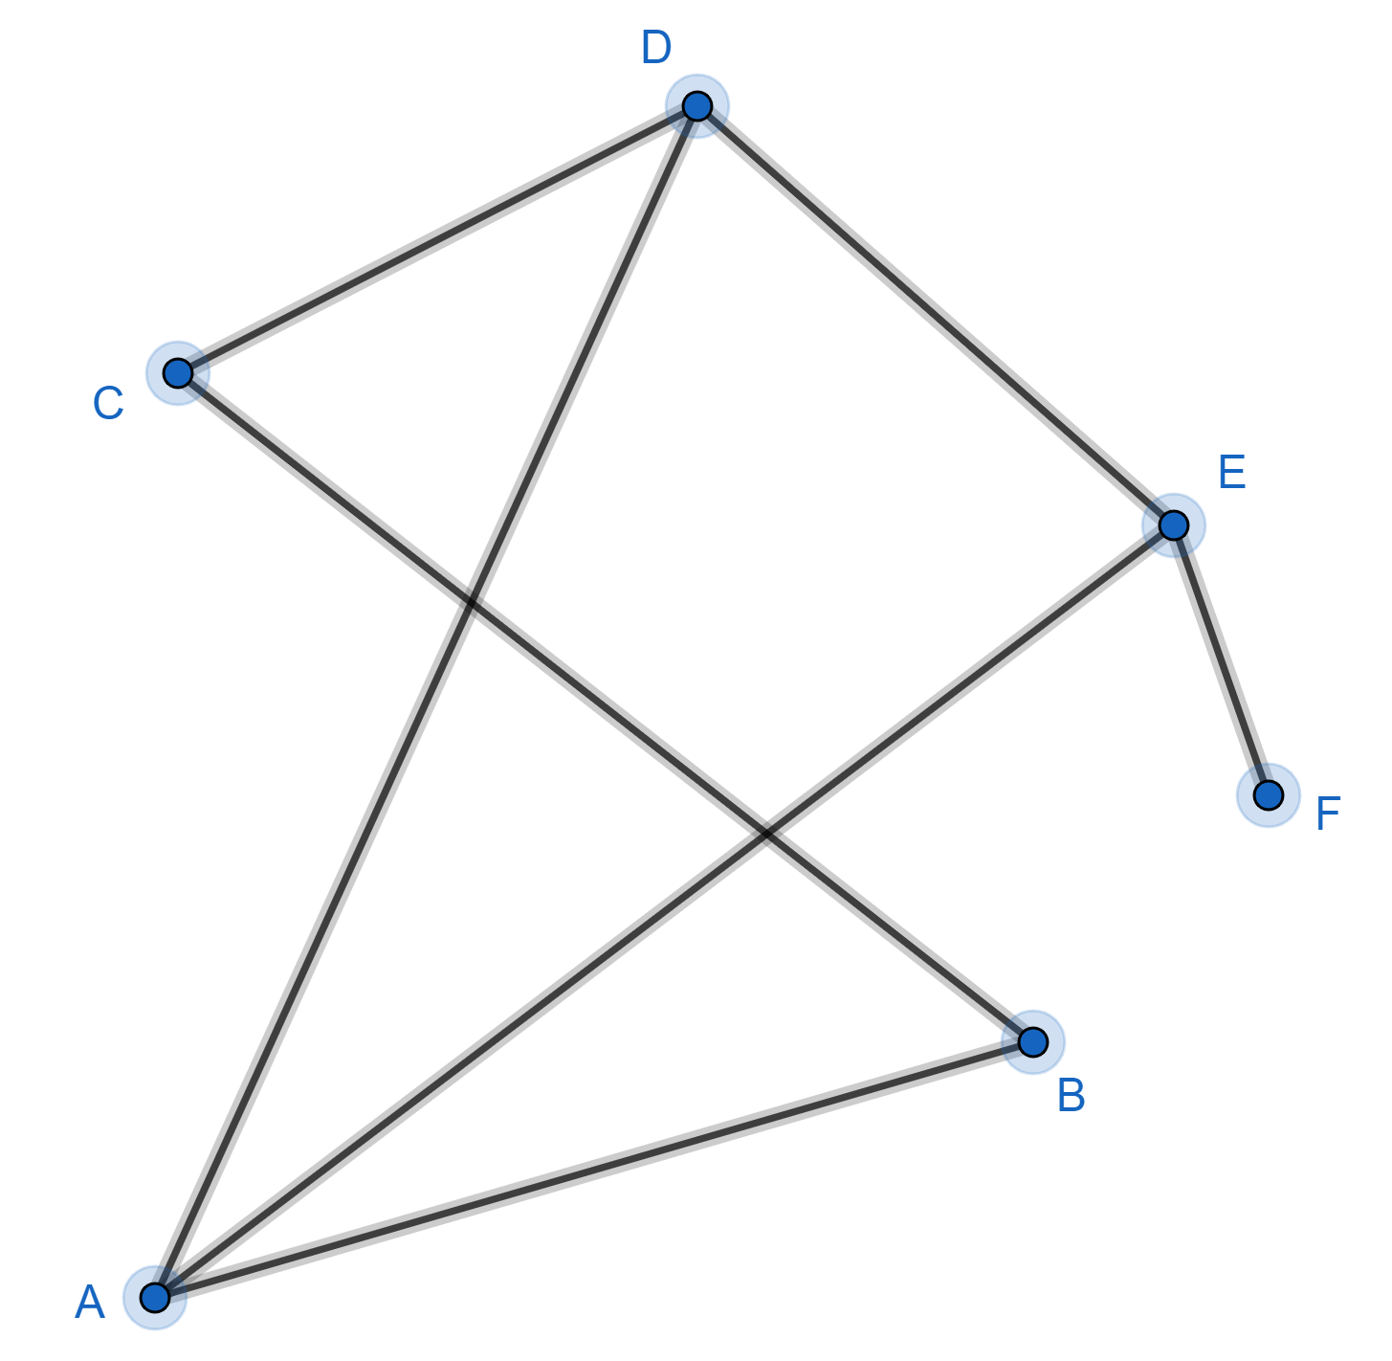

Note: this has nothing to do with graphs that haveandaxes.

We have points A, B, C, D, E, F (called vertices) connected by lines (called edges).
The degree of a vertex is the number of edges joined to that vertex.

vertex | A | B | C | D | E | F
degree | 3 | 2 | 2 | 3 | 3 | 1

The sum of the degrees of the vertices is
The number of edges is 7
Look at the edge AD. It is counted once when we find the degree of A and counted once again when we find the degree of D. This is true of all the edges. So ...
The handshaking rule:
For any graph, the sum of the degrees of the vertices is twice the number of edges.

We say a vertex is even if its degree is even and a vertex is odd if its degree is odd.
When you add up some positive integers the total will be even if and only if there are an even number of odd integers. The sum of the degrees of the vertices is even. So from the handshaking rule we can deduce:
For any graph, there are an even number of odd vertices.

Why is it called the handshaking rule?
Imagine A, B, C, D, E, F are people who went to a party. During the party, some handshaking took place. We recorded this on the graph.
A and D shook hands so our graph has an edge joining A and D.
B and F did not shake hands so our graph does not have an edge joining B and F.
Vertex D has degree 3, so D shook hands with 3 people.
At the end of the party we ask everyone how many hands they shook. The repliesadd up to 14. Each act of handshaking has been counted twice. When A and D shake hands, this contributes to A’s total and it contributes to D’s total. So the sum of the replies must equal twice the number of handshakes.

EXERCISE
Both these problems are about people at a party where handshaking took place.
1) Everyone shakes hands with 3 people. Why must there be an even number of people at the party?
2) Alice and Bill are at a party with 5 other people. Everyone shook hands with at least one other person. Only Alice and Bill shook hands with the same number of people. Why must Alice have shaken hands with an odd number of people?

SOLUTIONS
1) The sum of the degrees of the vertices is even. If each vertex has degree is 3 then there must be an even number of vertices.
2) There are 7 people at the party so everyone must have shaken hands with 1, 2, 3, 4, 5 or 6 people.
Alice shakes hands withpeople.
The other 6 people at the party each shook hands with a different number of people.
So the number of people they shook hands with must be 1, 2, 3, 4, 5 and 6
Nowmust be even somust be odd.

